1. ***Android Data Collection:***
2. ***Access the google drive android apps repo to get the list of android applications:***

***https://docs.google.com/spreadsheets/d/1gozRUgml6nCy_evCyQWzLrabhuKbRgMBJLD3Itg-NOQ/edit#gid=547704908***

***find the apks from the folder:***

[***https://drive.google.com/drive/u/1/folders/1Dl9wFfMH-nhlMe4aAmW6HMP3023rMhid***](https://drive.google.com/drive/u/1/folders/1Dl9wFfMH-nhlMe4aAmW6HMP3023rMhid)

1. ***Run the command to drive the callgraph and output data***

./gator a -p /mnt/h/ResearchSpace/Repositories/Android\ Projects/APKs/clickstack_v1.8.3.apk -client GUIHierarchyPrinterClient

***Replace the path in red with the path to the actual apk and run the android analysis. Add the command to the file “commands.txt” as shown in the screenshot.***

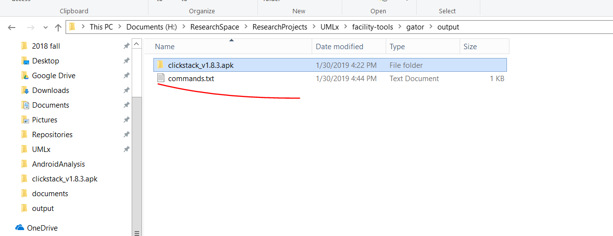

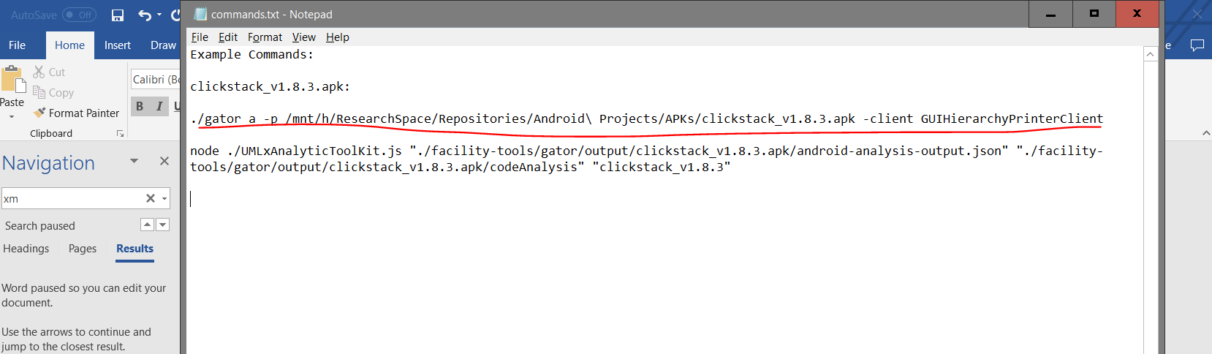

***The results can be found at the folder:***

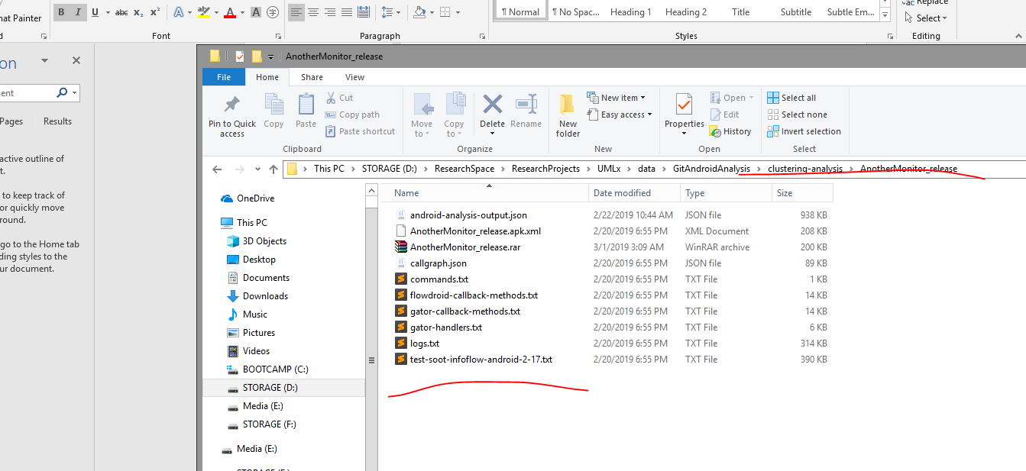

***Update the gator generated files into this folder:***

[***https://drive.google.com/drive/u/1/folders/1Y1-eWs4lL92z4RmCZkHWSPEnvpsNM8N2***](https://drive.google.com/drive/u/1/folders/1Y1-eWs4lL92z4RmCZkHWSPEnvpsNM8N2)

***and update the datasheet:***

[***https://docs.google.com/spreadsheets/d/1gozRUgml6nCy_evCyQWzLrabhuKbRgMBJLD3Itg-NOQ/edit#gid=547704908***](https://docs.google.com/spreadsheets/d/1gozRUgml6nCy_evCyQWzLrabhuKbRgMBJLD3Itg-NOQ/edit#gid=547704908)

1. ***Run the clustering analysis.***

***For each of the set of gator analysis result files, create three configuration files to point to the generated files.***

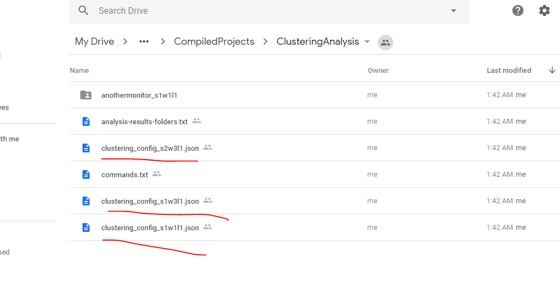

***Some of examples of the configuration files are here:***

[***https://drive.google.com/drive/u/1/folders/1cgxBTZwCC1FpkkE_QTh0XeMzp2FQ1R-Y***](https://drive.google.com/drive/u/1/folders/1cgxBTZwCC1FpkkE_QTh0XeMzp2FQ1R-Y)

***for example, for clustering_config_s1w1l1.json, the following field has be to consistent with the file name:***

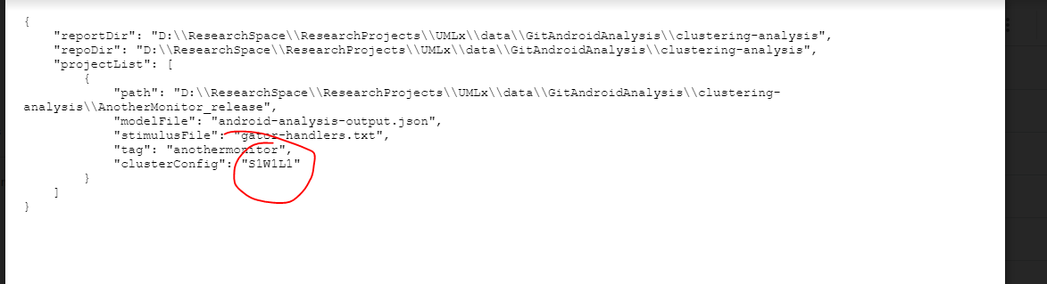

***For each of the three configurations files, run the corresponding command.***

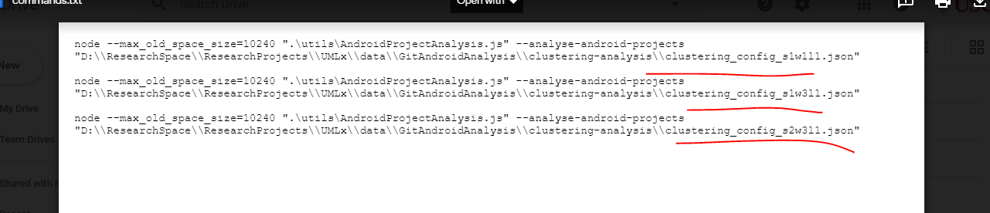

* ***The path should be replaced to your local environment.***

***The example commands are provided at this link:***

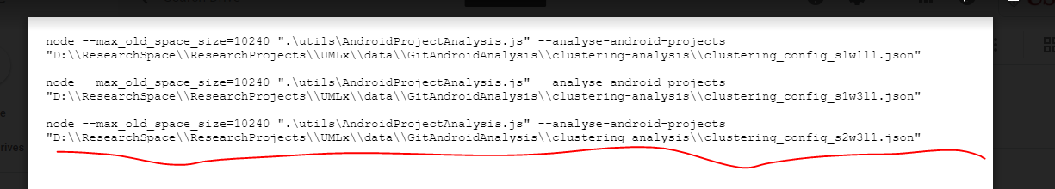

***Three folders are generated for each of the configuration file. An example of the generated folder is provided here:***

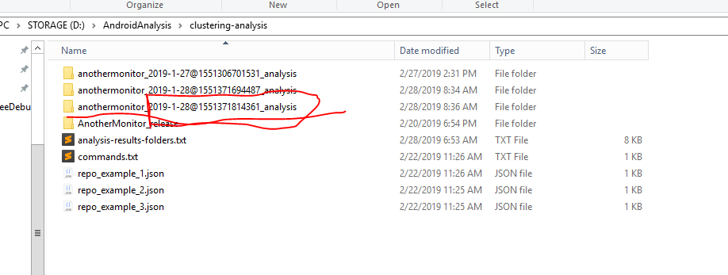

***Update the part of name of the folder to the same name of the config file.***

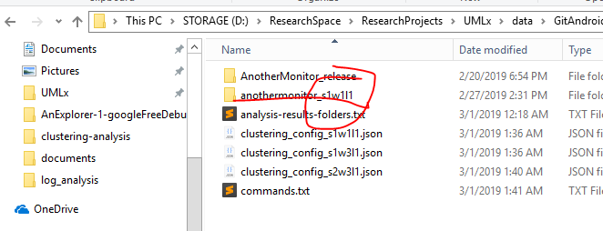

***Update the generated analysis files into this google drive folder:***

[***https://drive.google.com/drive/u/1/folders/1cgxBTZwCC1FpkkE_QTh0XeMzp2FQ1R-Y***](https://drive.google.com/drive/u/1/folders/1cgxBTZwCC1FpkkE_QTh0XeMzp2FQ1R-Y)

***and update the data sheets:***

[***https://docs.google.com/spreadsheets/d/1gozRUgml6nCy_evCyQWzLrabhuKbRgMBJLD3Itg-NOQ/edit***](https://docs.google.com/spreadsheets/d/1gozRUgml6nCy_evCyQWzLrabhuKbRgMBJLD3Itg-NOQ/edit)

***and :***

***https://docs.google.com/spreadsheets/d/17sTqNy4dq91VEoVFAE065I24IlNV6qfBH1mWRysSUK8/edit#gid=0***